Ceilometer monitoring of boundary layer height in Seoul and its application to evaluate the dilution effect on air pollution

Junhong Lee1, Je-Woo Hong1, Keunmin Lee1, Jinkyu Hong1†, Erik Velasco2, Yong Jae Lim3, Jae Bum Lee3, Travis Knepp4, Russell Long5, Lukas Valin5, Kipyo Nam3, Jihoon Park3

1Ecosystem-Atmosphere Process Laboratory, Department of Atmospheric Sciences, Yonsei University, Yonsei-ro 50, Seodaemun-gu, Seoul 03722, Korea

2Independent researcher, Singapore

3Climate and Air Quality Research Department, National Institute of Environmental Research, Incheon 22689, Korea

4Science Systems and Applications, Inc., Hampton, VA 23681, USA.

5Environmental Protection Agency, Research Triangle Park, Durham, NC 27709, USA.

†*Correspondence to:* Jinkyu Hong, Ecosystem-Atmosphere Process Laboratory, Department of Atmospheric Sciences, Yonsei University, Yonsei-ro 50, Seodaemun-gu, Seoul 03722, South Korea (E-mail: jhong@yonsei.ac.kr)

**Abstract**

The dilution effect caused by the evolution of the boundary layer has a strong influence on the air quality of any urban area. Accurate and continuous measurements of the boundary layer height over urban area (UBL) are therefore needed for a complete air quality assessment. Commercial ceilometers in combination with a reliable and simple methodology to measure attenuated aerosol backscatter profiles and retrieve the mixed layer height (*Z*ML) represent a means to obtain information on the vertical mixing and atmospheric structure above cities. Here, we evaluate various retrieval algorithms based on the gradient method against high temporal resolution radiosonde observations. Based on the results, we propose a new simple algorithm by optimizing the vertical and temporal moving averages, and first and second derivatives of such method, including a correction of background noise and using the minimum number of parameters that need to be locally adjusted to the landscape, climatology, boundary-layer properties, and the instrument itself. The proposed algorithm was tuned up for Seoul, Korea, and improved the retrieval performance of *Z*ML by reducing high frequency noises. The algorithm was used to investigate the relationship between the evolution of the daytime mixed layer height and air pollution under a two-layer mixing model where changes in concentrations depend only on the UBL growth. Using two months of ceilometer retrievals of *Z*ML and air quality data from across the city, we found strong negative correlations for primary emitted pollutants such as NO2, CO, SO2, and PM10, and a less strong positive correlation for O3. These findings provide insight on the significant influence of the UBL evolution on Seoul’s air quality.

**Keywords:** Ceilometer, Gradient method, Mixed layer height, Parameter optimization, Seoul’s air quality, Urban boundary layer

**1. Introduction**

The diurnal evolution of the urban boundary layer (UBL) is critical for a complete air quality assessment. The height of the UBL determines the extent of vertical mixing, and regulates the air quality variations within the urban dome together with the emission of toxic substances and particles, and their chemical processes. The roughness, land cover and evapotranspiration of the city, thermal mixing, emission of waste heat control the UBL dynamics (Stull 2012; Oke et al. 2017).

During daytime, convection and turbulence created by surface heating lead to the gradual growth of the UBL, mixing all pollutants within the convective mixed layer (ML). As its name implies, the ML homogenizes atmospheric properties so that vertical profiles of potential temperature, water vapor, concentration of pollutants, and wind speed and direction are almost uniform with height (Stull 2012; Oke et al. 2017). At the top of the ML is the entrainment zone, where air exchange with the free atmosphere (FA) occurs. This exchange might introduce cleaner or dirtier air into the UBL depending on the regional atmospheric pollution. At night the UBL shrinks as cooling at the surface usually creates a stagnant layer near the ground, which inhibits vertical mixing. This layer is called the nocturnal boundary layer (NBL). Above the NBL is the residual layer (RL) formed by the leftover constituents from the previous afternoon (Stull 2012; Oke et al. 2017).

As the ML evolves during daytime, primary pollutants from emission sources such as vehicular traffic and industry are diluted within a larger volume of air, which leads to cleaner air, if photochemical production and advection of polluted plumes have a minor contribution. In contrast, after sunset, when the UBL shrinks, air quality can deteriorate under a shallow UBL and strong emission of pollutants.

Despite the need for accurate knowledge of the diurnal evolution and dynamics of the UBL, continuous monitoring of the UBL is rarely performed. Radiosondes launched by meteorological services and airports are often used to retrieve UBL heights (*Z*△T). However, they are usually launched once or twice per day operationally. Recent improvements to remote sensing instruments, such as thermodynamic microwave radiometers, radar wind profilers and lidars have allowed continuous monitoring of the boundary layer evolution. Among these instruments, automatic lidars and their commercial version, ceilometers, offer a low-maintenance and low-cost solution to continuously monitor the ML using aerosol backscatter during daytime, as well as the NBL and RL at nighttime (e.g., Kim et al. 2007; Haman et al. 2012; Pandolfi et al. 2013; García-Franco et al. 2018; Kotthaus and Grimmond 2018b).

Ceilometers provide vertical profiles of backscatter aerosol backscatter of high spatial resolution (~15 m) up to 5-8 km at temporal resolutions of tens of seconds (1-30 s). These continuous observations require reliable post-processing methods to detect the height of ML (*Z*ML). Methods of different complexity have been proposed and evaluated for urban atmospheres (e.g., Hayden et al. 1997; Menut et al. 1999; Steyn et al. 1999; Seibert et al. 2000; de Haij et al. 2006; Eresmaa et al. 2006, 2012; Sicard et al. 2006; Münkel et al. 2007; Emeis et al. 2007; Compton et al. 2013; Sokół et al. 2014; Lotteraner and Piringer 2016; Kotthaus et al. 2016; Tang et al. 2016; Caicedo et al. 2017; Kotthaus and Grimmond 2018a). Among the available methods to retrieve *Z*ML, the gradient method has been widely used because of its relative ease of application. Here, we evaluate five variations of this method and propose an improved simple scheme of the same method based on a parameter optimization of empirical coefficients. The parameters are needed to be adjusted to local environmental characteristics in aspects of a noise filtering and relationship between the aerosol mixing layer and temperature inversion layer in the boundary layer, which is not documented clearly in previous studies. The performance of these six retrieval methods is tested using a dataset of attenuated aerosol backscatter profiles measured by a Vaisala CL-31 ceilometer and high temporal resolution radiosondes launched simultaneously in the metropolitan area of Seoul, Korea.

To investigate the relationship between the evolution of the UBL and air pollution at ambient level, we investigate the application of inverse regressions of first order between the retrieved *Z*MLand air quality data from the local monitoring network. Even though Korea has implemented stringent control measures to reduce the domestic emission of pollutants, the rapid industrialization and urbanization of East Asia have hampered to some extent such measures (e.g., Lee et al. 2011, 2013; Vellingiri et al. 2015; Chambers et al. 2017; Tang et al. 2018). To investigate the impact of regional air pollution over Seoul we use data from a background air quality monitoring station to determine the height at which the local pollution reaches its regional levels for the cases of sulfur dioxide (SO2), carbon monoxide (CO), nitrogen dioxide (NO2), ozone (O3), and particulate matter smaller than 10 µm (PM10).

**2. Methods and aerosol backscatter retrieval evaluation**

The study is based on a two-month campaign (1 May-28 June 2016) of continuous backscatter profile measurements by a ceilometer installed on the rooftop of a tall building at Yonsei University within the urban core of Seoul (37.57° N, 128.98° E, building height: 30 m, 80 m above sea level). On 29 December 2016, eighteen radiosondes were launched from the same building to test the performance of the retrieval algorithms based on the gradient method mentioned above.

This section firstly provides a complete description of the ceilometer measurements and *Z*ML retrieval procedure. Then, the proposed parameterization of empirical coefficients for an improved retrieval algorithm based on the gradient method is introduced step by step, followed by details of the radiosonde measurements used for its evaluation. Results of this evaluation and comparisons against the other five algorithms are discussed after. Finally, information on the air quality data used to investigate the relationship between the UBL dynamics and air pollution is provided.

**2.1. Ceilometer measurements**

As already indicated, a laser ceilometer (CL-31, Vaisala Inc., Finland) was used to investigate the UBL evolution over Seoul. This commercial ceilometer is equipped with an eye-safe 910-nm wavelength indium gallium arsenide diode laser and a single coaxial-design lens used for both an emitter and a receiver (firmware version 2.027). It has a maximum detection height of 7.5 km. The spatial and temporal resolutions are 10 m and 16 s, respectively. The backscatter readings were recorded by a computer and post-processed using an averaging period of 1 hour to obtain *Z*ML data.

**2.2. Boundary layer height retrieval procedure**

A ceilometer measures the attenuated backscatter (*B*(*z*)) of light by aerosols including cloud and fog drops, and particulate matter (PM) where *z* indicates the *zth* level of ceilometer data from the bottom (i.e., the actual height is *z* × 10 m). Accordingly, higher aerosol concentrations within the UBL create a sharp variation of *B*(*z*) across the top of the UBL; thus enabling a measurement of the *Z*ML to be made by a ceilometer. Among the different methods to retrieve the *Z*ML from attenuated aerosol backscatter vertical profiles, the gradient method has been widely used because of its ease of application compared to other methods, and accurate results when it is properly adjusted to the conditions of the site and hardware characteristics.

The gradient method defines the *Z*ML as the height of the minimum vertical gradient of *B*(*z*). This minimum can be determined as the largest negative peak of the first derivative of *B*(*z*) (Hayden et al. 1997; Flamant et al. 1997) or by the second derivative (Menut et al. 1999). Similarly, the largest negative gradient in the logarithm of *B*(*z*) can be also used to detect the top of the ML (Senff et al. 1996). Emeis et al. (2007) refined the gradient method to detect the inflection point using the derivative of *B*(*z*) and five adjustable parameters. Recently, based on Emeis et al. (2007), Kotthaus and Grimmond (2018a) proposed an algorithm to retrieve *Z*ML from a ceilometer by considering cloud to reduce false layer selection. Here, we extend the gradient method by Emeis et al. (2007) by focusing on parameter optimization for better filtering of ceilometer noise. It is also based on the first and second derivative, but only three parameters need to be adjusted.

In brief, the algorithm proposed by Emeis et al. (2007) is as follows. Prior to the determination of the inflection point, the overlap and range of*B*(*z*) are averaged over time and height to suppress noise artefacts. The noise artefacts are caused by ceilometer hardware (e.g., transmitter, electronic noise, and optical noise contaminated by sun) and firmware, and cosmetic shift on the signal and therefore must be filtered properly to reduce noise contamination of *B*(*z*). Then, *Z*ML is determined, firstly within a vertical moving average window (*w*v) from 140 m to 500 m at vertical intervals (∆*z*) of 80 m over averaging periods (*w*t) of 15 min. Then, in a layer between 500 m and 2000 m using ∆*z* of 160 m. The minimum threshold value of *B*(*z*) (*B*min) and maximum threshold value of the first derivative (∂*B*/∂*z*)max below a lifted inversion must be 200 × 10-9 m-1 sr-1 and < -0.30 × 10-9 m-2 sr-1 in the lower layer, and 250 × 10-9 m-1 sr-1 and < -0.60 × 10-9 m-2 sr-1 in the upper layer. The first and second derivatives (∂2*B*/∂*z2*) are calculated by Eqs. 1 and 2. *B*min occurs when ∂2*B*/∂*z2* passes from positive to negative values, and if the conditions regarding *B*min and ∂*B*/∂*z* stated above are met, the height of *B*min will correspond then to *Z*ML. For details see Emeis et al. (2007, 2008).

(1)

(2)

The variations to the method of Emeis et al. (2007) (hereafter, EE07) proposed here aim to reduce potential overestimations of *Z*ML and the number of parameters that need to be adjusted together. Adjustable parameters are related to spatial and temporal averages both to filter out ceilometer-reported noise and to preserve meaningful signal. Through comparisons against *Z*ML retrieved from radiosonde data measured during 0500-2300 local standard time (LST) on 29 December 2016 (see section 2.3 for detail), we optimized such parameters, *w*v, *w*t and ∆*z.* The parameters were optimized for daytime and nighttime separately based on time of sunrise and sunset and these optimized parameters were evaluated in May 2016. Emeis et al. (2007) used *B*min and (∂*B*/∂*z*)max to determine *Z*ML; here *B*min is estimated from the ceilometer itself using the averaged *B*(*z*) in the FA during clear nighttime. Kotthaus et al. (2016) proposed this as a sort of background correction to remove erratic changes in *B*(*z*). It works because the signal-to-noise ratio of *B*(*z*) is low at high altitudes (making *B*(*z*) < 0), and the minimum of ∂*B*/∂*z* frequently occurs at high altitude accordingly, leading to abnormally high *Z*ML.

The proposed method to retrieve *Z*ML from attenuated aerosol backscatter profiles can be summarized in three main steps as follows:

1) Vertical and temporal moving averages, *w*v and *w*t, are applied to minimize noise artefacts when computing the first and second derivatives according to Eqs. 1 and 2. These parameters are optimized for daytime and nighttime separately, considering only one layer and not two as in Emeis et al. (2007), so reducing to one set of parameters needed per retrieval.

2) Inflection points are detected from ∂2*B*/∂*z2*, when its values are negative and pass from positive to negative.

3) The three lowest heights among the inflection points are selected as *Z*ML potential candidates. The averaged *B*(*z*) should be larger than the *B*min obtained from the background correction filter of Kotthaus et al.(2016).

4) *Z*ML is decided as the height of the smallest value of ∂*B*/∂*z* among the three inflection points selected as potential candidates. The maximum ∂*B*/∂*z*, which was used in Emeis et al. (2007), is not required accordingly.

(3)

The performances of these changes to the gradient method of Emeis et al. (2007) (E07) were evaluated through comparisons of a set of *Z*△T obtained from radiosondes profiles and *Z*ML obtained from the original algorithm of Emeis et al. (2007) and other four variations of the gradient method. The latter included *Z*ML derived from the first derivative (FIR), second derivative (SEC), logarithmic derivative (LOG), and CL-31 built-in software (Vaisala sky condition, VAI) (Münkel et al. 2007; Vaisala Oyj 2011). Table 1 lists the main characteristics and parameters to adjust of each one of these versions of the gradient method.

Through a sensitivity analysis, the appropriate values of *w*v, *w*t and ∆*z* were determined for FIR, SEC, LOG, E07, and EE07 algorithms separating daytime and nighttime periods. These optimum values were chosen as those for which the root mean square error (RMSE) of the derived *Z*ML against the *Z*△T obtained from radiosonde data presents a minimum. These parameters could not be optimized for VAI and the parameters proposed by Münkel et al. (2007) were used instead. It is important to note that the suggested values for these parameters depend not only on properties of boundary layer properties and free atmosphere such as temperature gradient and aerosol concentration, but also on ceilometer characteristics (e.g., firmware, hardware, and raw data acquisition setting), thus showing spatio-temporal variations. The optimized parameters were tested in another season, May 2016. Section 2.4 discusses the performance of the six different retrieval methods using as reference *Z*△T derived from radiosondes.

**2.3. Radiosonde measurements**

A series of air temperature and wind profiles derived from radiosondes (RS41-SG, Vaisala, Finland) were obtained to evaluate the performances of the *Z*ML retrieval algorithms. Radiosonde transmits GPS (Global Positioning System) location, altitude, pressure, temperature, humidity, wind speed, and wind direction. Pressure measurement of radiosonde had a resolution of 0.01 hPa and an accuracy of 0.3-1.0 hPa. Temperature had a resolution of 0.1 ºC, an accuracy of 0.1 ºC to 0.4 ºC, and a response time of 0.5 s. Humidity had a resolution of 0.1%, an accuracy of 2% to 4%, and a response time of < 0.3 s at 20 ºC. Wind speed and direction had resolutions of 0.1 m s-1 and 0.1 degree and accuracies of 0.15 m s-1 and 2 degrees, respectively. The averaged ascent rate of the radiosonde was ~2 m s-1 for high vertical resolution.

Eighteen radiosondes were launched on 29 December 2016 from the rooftop of the building that hosted the CL-31 ceilometer. The radiosondes were launched at intervals of 1 hour starting at 0500 LST and ending at 2300 LST. Sky conditions were clear during the radiosonde observations, except for the first launch at 0500 LST when the sky was partially overcast. The *Z*△T derived from the radiosonde data was determined as the layer at the maximum of potential temperature gradient during daytime (Seibert et al. 2000; Seidel et al. 2010) and top of the inversion layer at the lowest altitude during nighttime (Seidel et al. 2010). The representative radiosonde profiles indicate typical profiles of potential temperature and potential temperature gradients, and wind speed, with *Z*△T during daytime and nighttime (Fig. 1).

For further verification of the algorithms, other air temperature profiles in May 2016 were used to derive *Z*△T from radiosonde measurements during the intensive field campaign. Four radiosondes were launched at daytime on 17, 27, 30, and 31 May 2016 at the Olympic Park of Seoul, during the Korea-United States Air Quality (KORUS-AQ) field campaign (Tang et al. 2018).

**2.4. Air quality data**

Air quality data from 38 monitoring stations across the metropolitan area of Seoul and the national background monitoring station of Baengnyeong island were used to investigate the relationship between the evolution of the UBL and air pollution at an ambient level. The air quality data included ambient concentrations of SO2, CO, NO2, O3 and PM10.The air quality monitoring station of Baengnyeong island is located 200 km to the west of Seoul and 250 km from the Shandong Peninsula, China. No urban settlement or large emission source affects Baengnyeong island, and therefore, its air quality is representative of the regional background.

All monitoring stations have sampling rates of 5 min with averaging periods of 1 hour. Measurements of SO2, CO, NO2, O3, and PM10 were based on pulse UV fluorescence (SA-731, KIMOTO, Japan), non-dispersive infrared (CA-751, KIMOTO, Japan), chemiluminescent (NA-721, KIMOTO, Japan), UV photometric (OA-781, KIMOTO, Japan) and β-ray absorption (PM-711, KIMOTO, Japan) methods, respectively. Quality assurance was applied based on guidelines for the air quality monitoring network of the Korean Ministry of Environment (KME 2016a).

**3. Results**

This section presents the diurnal variations of the *Z*ML retrieved from the aerosol backscatter measurements during the two-month campaign and companion air quality data. The latter is used to investigate the dilution effect on air pollution within the city as the ML evolves during daytime through the application of inverse regressions of first order between *Z*ML and pollutant concentrations.

**3.1. Evaluation of six gradient methods to retrieve ceilometer’s *Z*ML**

The optimal *w*v and *w*t as a function of ∆*z* were determined by the smallest RMSE between the estimated *Z*ML by the retrieval algorithms FIR, SEC, LOG, E07, and EE07 and *Z*△T obtained from the set of radiosonde profiles. The parameters in the algorithm provided by the ceilometer manufacturer, VAI, could not be adjusted. Table 2 shows the values of the optimized parameters and respective skill scores (RMSE, mean bias error, and correlation coefficient (*r*2)). As expected, the improved method EE07 showed the best performance during both, daytime and nighttime with the best skill scores. During daytime the optimized algorithms (i.e., FIR, LOG, and E07) and VAI algorithms with the optimization also showed good performance, but not during nighttime. Importantly, the algorithms, FIR, LOG, and E07, better reproduced the radio-sonde reported boundary layer height if the optimized parameters were used. The method based on the second derivative, SEC, showed a consistent underestimation of *Z*ML during daytime and early morning. Optimized algorithm of Emeis et al. (2007) showed overestimation during the complete diurnal course and mean bias error of 371.5 (1136.6) m during daytime (nighttime).

Daytime convective conditions are favorable for slowly varying larger eddies compared to nighttime condition (Stull 2012). Moving average works as a low pass filter and its frequency response is a sinc function (Finnigan 2006). In this perspective, the larger *w*v in daytime permits us to use strong criterion to remove contamination due to high frequency noises. It also tells us that our estimation in nighttime is more uncertain in nighttime since we need smaller *w*v to resolve smaller boundary layer structure from high frequency noise. Larger averaging time in nighttime compensated for uncertainties due to smaller *w*v and suggests that the boundary layer did not change abruptly in nighttime conditions at the site. However, our results indicate that nocturnal estimation of ML is more uncertain and further study is demanding to understand spatio-temporal variability of nocturnal boundary layer and its impacts on ceilometer-reported boundary layer height. Turbulent mixing is still possible above the temperature inversion in case of strong updraft and entrainment with the overlaying FA. This suggests that the entrainment zone was relatively larger in daytime, producing larger ∆*z* and *w*v.

Figure 2 shows the evolution of the *Z*△T obtained from the radiosondes data and six different retrieval algorithms for the evaluated period of 18 hours. The radiosonde retrievals showed the typical diurnal variation of *Z*△T (Stull 2012). The growth of the convective ML started with the radiative heating after sunrise at 0900 LST, reaching a maximum of 1272 m at noon. It maintained heights over 1000 m during the afternoon. After 1600 LST it started to collapse. By 1800 LST an NBL of ~200 m had been formed. The intense nocturnal release of heat stored by the urban fabric during daytime (Hong and Hong 2016) was apparently capable of maintaining such a height throughout the rest of the night.

Notably, the improved version of the original gradient method of Emeis et al. (2007) with the parameter optimization tuned to the local conditions was able to reproduce the observed diurnal variation of the ML over urban region. During daytime, no major difference was observed against the *Z*△T retrieved from radiosonde profiles. The morning growth and evening collapse of the ML were well reproduced. At nighttime, several inflection points can exist if RL is formed by leftover constituents from daytime UBL. In this case, the minimum gradient of *B*(*z*) can be in the RL so that a ceilometer misleads our estimation of the nocturnal mixing layer. Such RL prohibits us from retrieving reliable boundary layer height as previous studies pointed out.

Indeed, during nighttime, especially after 1800 LST, EE07 underestimated the NBL height despite the parameter optimization. In the early morning (i.e., before 0800 LST) this disagreement was not clear since two of three retrievals were overestimated as a probable consequence of the differences in the methods to determine ZML and *Z*△T when using ceilometer and radiosonde data, as discussed in Caicedo et al. (2017). However, our results based on the parameter optimization indicates that weak signal change at the stable boundary layer can be detected by applying filtering techniques generally and that our findings suggest that parameter optimization is fundamental to obtain accurate retrievals of *Z*ML. Further verification with daytime radiosondes in May 2016 confirms that the parameter optimization is necessary to reproduce the observed boundary layer height (Table 3).

The better performance shown by EE07 is explained by 1) the combination of first and second derivatives of *B*(*z*) to select inflection points in the attenuated aerosol backscatter profile, thus there are fewer parameters to adjust and alleviation of the overestimation by E07; 2) the *B*min based on the averaged background *B*(*z*) during nighttime in the free troposphere under clear conditions helps to remove erratic changes in *B*(*z*); and 3) the parameters are optimized using direct measurements of *Z*△T obtained from radiosonde data.

**3.2. Diurnal variation in the *Z*ML**

Figure 3 shows the time series of *Z*ML retrieved throughout the complete campaign using the improved version of the gradient method of Emeis et al. (2007) developed here. Figure 4 shows the ensemble diurnal variations of the ML evolution for each monitored month. The daily profiles during both months were similar to those obtained from the radiosonde thermodynamic profiles shown in Fig. 2. The mean *Z*ML during daytime (0500 – 2000 LST) was 1007.3 (838.0 – 1148.7) (median (IQR)) and 1112.2 (965.6 – 1275.6) m in May and June, reaching maximum heights of 1342.4 (1194.3 – 1628.3) and 1390.7 (1302.5 – 1582.0) m at 1400 LST for both months. The convective ML started to collapse consistently after 1700 LST. By 1900 LST it had completely collapsed, giving place to a shallow NBL of 161.0 (297.9 – 569.5) and 392.3 (233.3 – 649.2) m. The minimum *Z*ML had a deep of 91.7 (90 – 165.5) and 98.1 (90 – 112.3) m at 2000 LST in May and at 1900 LST in June, respectively.

On 6 (4) days the ML reached heights over 1500 m in May (June). Similarly, 45.2 (78.6)% of the days registered maximum *Z*ML > 1250 m, 45.2 (21.4)% between 1000 and 1250 m, and 9.7 (0.0)% < 1000 m. Regarding to the NBL height, 41.9 (21.4)% of the days presented depths < 200 m, 35.5 (35.7)% between 200 and 300 m, and 22.6 (42.9)% > 300 m. Although smaller convective ML and NBL were reported in May than in June, the differences between both months were not statistically significant (*p* > 0.05). The slightly smaller *Z*ML and larger day-to-day differences, shown by the vertical bars in Fig. 4, were due to more frequent precipitation events in May.

It is well known that *Z*ML retrieval algorithms based on the gradient method do not provide reliable values during and after periods affected by rain (e.g., Haman et al. 2012; Caicedo et al. 2017; Kotthaus and Grimmond 2018a). Our ceilometer retrievals also showed suspicious variations in the *Z*ML during rainfall. There were 12 precipitation events during the campaign and the ceilometer measured very large *B*(*z*) as a consequence of raindrop interference along the optical path. In general, cloud makes significant change in *B*(*z*) and boundary layer cloud can be resolved in *B*(*z*). Our proposed method defined such cloud base as the boundary layer top. However, in case of the boundary layer cloud, typical properties of the boundary layer are not clearly defined (Stull 2012). Accordingly, our analysis on air pollutant in the next sub-section focuses on clear daytime condition and more work is needed for reliable estimation of the boundary layer height from a ceilometer.

On a couple of occasions, the convective ML did not collapse rapidly after sunset according to our retrievals, instead it continued evolving even until the early morning. Obviously, this was a failure of our algorithm EE07 to retrieve properly the *Z*ML at nighttime. On those days, the level of aerosols in the RL might have been higher than within the NBL, and the retrieval algorithm had erroneously detected the top of such layer as the *Z*ML. It is because pools of polluted air can stay in a RL detached from the surface as a result of an abrupt collapse of the convective ML as we discussed in previous section (Stull 2012).

**3.3. Diurnal variations on air quality**

Figure 5 shows the monthly ensemble diurnal patterns of ambient concentration for the five criteria pollutants monitored across 38 stations in the metropolitan area of Seoul that was used in this study to investigate the relationship between the *Z*ML and local air quality. Background concentrations of air pollutants within the study area are larger than those in Europe and North America (e.g., Akimoto 2003), and show relatively smaller diurnal variations, which probably reflects the absence of emission sources over the Yellow Sea (Fig. 5). Interestingly, the background O3 concentration is much higher than reported in an upstream region by Tang et al. (2012). In the Seoul metropolitan area, SO2, CO, and NO2 consistently show higher concentrations compared with background values, which is consistent with annual reports by the Korea Ministry of Environment (KME 2016b). The larger air pollutant concentration in Seoul indicates that the dilution effect of air pollutants due to the boundary layer stretching can be investigated by a two-layer mixing model.

We can divide these five pollutants into three categories according to their diurnal pattern characteristics. SO2, CO, and NO2 form a first category (Fig. 5). They are primary emitted pollutants whose ambient concentrations follow closely the diurnal pattern of anthropogenic activities within urban areas. They showed the typical morning and evening rush-hour peaks caused primarily by traffic emissions. The evolution of the convective ML throughout the day and the photochemical activity enhance the dimension of these peaks. As expected, the background concentrations of these pollutants were relatively constant throughout the day and smaller to those observed within Seoul.

PM10 forms the second category of pollutants. Its ambient concentrations do not present a bimodal diurnal profile like the pollutants of the first category. The difference between the background and urban concentrations was small or null, but during high concentration episodes associated with westerly winds, the concentrations at the Baengnyeong island were in occasions significantly higher. A cross-correlation analysis between concentrations at both locations shows a consistent time lag of ~7 hours, particularly during high concentration episode (not shown). This result suggests that an important fraction of PM10 over Seoul has a long-distance origin, decreasing the relevance of locally-emitted particles (Lee et al. 2011, 2013).

The third category covers pollutants of secondary origin, like O3 in our case. The diurnal variations of O3 in Seoul, like in many other cities, are inversely related to those of many primary emitted pollutants. In general, solar radiation triggers its formation in the presence of two major groups of precursor species, volatile organic compounds (VOCs) and nitrogen oxides (NOx = NO + NO2) (see Vellingiri et al. (2015) and Iqbal et al. (2014) for detailed information about Seoul’s O3 pollution). Thus, the buildup of O3 starts after sunrise and reaches its peak at ~1500 LST. Then, it decreases gradually throughout the rest of the day. At nighttime the O3 removal by titration is enhanced by fresh emissions of NO that is accumulated in a shallow NBL. Despite the dilution effect due to deep mixed layer height in the afternoon, O3 shows the maximum around 1600 LST. This maximum O3 in the late afternoon can be caused by two processes: (1) the photochemical O3 formation overwhelms the dilution effect and (2) the entrainment process with the overlaying FA increases O3 concentration during the study period because unlike SO2, CO, and NO2, the background concentration of O3 was higher than in Seoul for most of the time (Zhang and Rao 1999; Schäfer et al. 2006; Shiu et al. 2007).

**3.4. Relationship between ML height and air pollution**

To investigate the dilution effect on air pollution caused by the evolution of the convective ML during daytime over the metropolitan area of Seoul, we applied a simplified two-layer mixing model between the ML and overlying FA, giving inverse relationships of first order between the observed concentration of pollutants and *Z*ML. The assumptions under this model are: 1) ambient concentrations are representative of concentrations within the entire ML, 2) entrainment process of air in the ML with the overlying FA occurs over a relatively short period, such that the time lag between changes in the *Z*ML and pollutants concentrations is negligible, 3) contributions by advection to the pollutant are neglected, 4) emission and deposition are not considered, and 5) photochemical activity is much less relevant than the stretching of the ML.

Figure 6 shows the inverse regressions of the first order for each one of the pollutants studied here. The two-layer mixing model well explained the observed temporal variation of all the pollutant concentration across the city with *r*2 > 0.57 except O3. PM10, CO, SO2, and NO2 showed clearly negative correlations, opposite to O3. These results are consistent with similar studies (Schäfer et al. 2006; Tang et al. 2016; Leng et al. 2016). The correlation coefficients ranged from 0.31 for O3 to 0.76 for CO. The stronger correlation for CO can be explained by its low chemical reactivity and main origin from anthropogenic sources within the city. NO2 and PM10 also showed strong correlations of 0.60 and 0.66, respectively. Importantly, despite the severe limitations of the simple model, the relatively strong correlations provide insight on the significant influence of the ML evolution and entrainment process on air quality in the Seoul metropolitan area.

All regressions reach a point from which pollutants concentration shows the asymptotic change (decrease or increase) as a function of *Z*ML. For the case of O3, this equilibrium point occurs when its concentration starts to decrease at a *Z*ML of 1100 m and a related concentration of ~50 ppb (see Fig. 6d). At this height, the concentrations of the other pollutants do not vary significantly anymore, suggesting that O3 has reached its background concentration. For the case of PM10, concentration is similar to those reported at the background site at this height. Our results on the two-layer mixing model proposed that the entrainment process was dominant in this area and more study is required to quantify the contribution of the entrainment process with higher background O3 and photochemical O3 formation in this area.

**4. Summary and conclusions**

This study evaluated the dilution effect caused by the ML evolution by measuring the temporal variations of the *Z*ML over the Seoul metropolitan area from November to June when air pollution is most severe. To retrieve accurate and continuous *Z*ML from attenuated aerosol backscatter profiles measured by a commercial ceilometer, we evaluated and optimized various retrieval algorithms based on the gradient method using high temporal resolution radiosonde observations. A sensitivity analysis showed that all methods with parameter optimization reproduced the observed *Z*△T during daytime. This result demonstrated that simple gradient methods produce reliable height estimations of the convective ML when parameter optimization is applied, but not of the NBL. Based on this finding, we proposed an improved algorithm by optimizing the vertical and temporal moving averages, and first and second derivatives of the gradient method developed by Emeis et al. (2007) using a minimum number of parameters that need to be locally adjusted, and including a background noise correction. This algorithm delivered improved estimations of *Z*ML, even the NBL height. Given the extended use of ceilometers in recent years, future work should focus on the evaluation of the proposed parameter optimization in other geographical locations.

Using the *Z*ML retrieved by our improved gradient method, we investigated the relationship between the ML height and air pollution data reported by the local air quality monitoring network during our two-month campaign. Across the city, concentrations of primary emitted pollutants such as SO2, CO, and NO2 were found to be consistently higher than those at a background site, whereas concentrations of PM10 and O3 were similar or lower, respectively.

The *Z*ML showed a negative correlation against PM10, CO, SO2, and NO2, but a positive correlation against O3. These correlations were based on a two-layer mixing model, in which changes in concentration depend only on the ML growth and entrainment from the FA. Despite neglecting advection, photochemistry, emissions, and deposition, we found strong correlation coefficients, particularly for CO, NO2, and PM10. Our findings provide insight on the significant influence of the ML evolution on Seoul’s air quality. Our study indicates that entrainment from the overlying FA, which has been neglected in many applications, plays an important role in regulating air pollution in this area.

Continuous monitoring of the *Z*ML and air quality will allow understanding the influence of the UBL climatology on the local air pollution. It will provide information to elucidate the seasonal contribution of convective dilution to ambient pollution. Reliable and continuous retrievals of the *Z*ML will help to verify the accuracy and tune up existing parameterizations of the UBL evolution in meteorological models, as well as provide confidence on air quality models used to evaluate the efficiency of new control measures.

**Acknowledgements**

This study was supported by the Korea Polar Research Institute (KOPRI, PN18081) and the National Research Foundation of Korea grant funded by the Korean government (MSIT) (No. NRF-2018R1A5A1024958). The second author was supported by the Global Ph.D. Fellowship Program (NRF-2015H1A2A1030932). The *Z*ML and air pollution data used in this study are available at https://doi:10.22647/EAPL-LEE2017A. There are no conflicts of interest to declare.

**References**

Akimoto H (2003) Global air quality and pollution. Science 302: 1716-1719

Caicedo V, Rappenglück B, Lefer B, Morris G, Toledo D, Delgado R (2017) Comparison of aerosol lidar retrieval methods for boundary layer height detection using ceilometer aerosol backscatter data. Atmos Meas Tech 10:1609-1622

Chambers SD, Kim KH, Kwon EE, Brown RJ, Griffiths AD, Crawford J (2017) Statistical analysis of Seoul air quality to assess the efficacy of emission abatement strategies since 1987. Sci Total Environ 580:105-116

Compton JC, Delgado R, Berkoff TA, Hoff RM (2013) Determination of planetary boundary layer height on short spatial and temporal scales: a demonstration of the covariance wavelet transform in ground-based wind profiler and lidar measurements. J Atmos Ocean Technol 30:1566-1575

de Haij M, Wauben W, Baltink HK (2006) Determination of mixing layer height from ceilometer backscatter profiles. In Remote Sensing of Clouds and the Atmosphere XI, 11 October, 2006, Stockholm, Sweden, pp 63620R

Emeis S, Jahn C, Münkel C, Münsterer C, Schäfer K (2007) Multiple atmospheric layering and mixing-layer height in the Inn valley observed by remote sensing. Meteorol Z 16:415-424

Emeis S, Schäfer K, Münkel C (2008) Surface-based remote sensing of the mixing-layer height–a review. Meteorol Z 17:621-630

Eresmaa N, Karppinen A, Joffre SM, Räsänen J, Talvitie H (2006) Mixing height determination by ceilometer. Atmos Chem Phys 6:1485-1493

Eresmaa N, Härkönen J, Joffre SM, Schultz DM, Karppinen A, Kukkonen J (2012) A three-step method for estimating the mixing height using ceilometer data from the Helsinki testbed. J Appl Meteorol Climatol 51:2172-2187

Finnigan J (2006) The storage term in eddy flux calculations. Agric For Meteorol 136: 108-113

Flamant C, Pelon J, Flamant PH, Durand P (1997) Lidar determination of the entrainment zone thickness at the top of the unstable marine atmospheric boundary layer. Boundary-Layer Meteorol 83:247-284

García-Franco JL, Stremme W, Bezanilla A, Ruiz-Angulo A, Grutter M (2018) Variability of the mixed-layer height over Mexico City. Boundary-Layer Meteorol. https://doi.org/10.1007/s10546-018-0334-x

Haman CL, Lefer B, Morris GA (2012) Seasonal variability in the diurnal evolution of the boundary layer in a near coastal urban environment. J Atmos Ocean Technol 29:697-710

Hayden KL, Anlauf KG, Hoff RM, Strapp JW, Bottenheim JW, Wiebe HA, Froude FA, Martin JB, Steyn DG, McKendry IG (1997) The vertical chemical and meteorological structure of the boundary layer in the Lower Fraser Valley during Pacific'93. Atmos Environ 31:2089-2105

Hong JW, Hong J (2016) Changes in the Seoul metropolitan area urban heat environment with residential redevelopment. J Appl Meteorol Climatol 55:1091-1106

Iqbal M, Kim K, Shon Z, Sohn J, Jeon E, Kim Y, Oh J (2014) Comparison of ozone pollution levels at various sites in Seoul, a megacity in Northeast Asia. Atmos Res 138:330-345

Kim S, Yoon S, Won J, Choi S (2007) Ground-based remote sensing measurements of aerosol and ozone in an urban area: A case study of mixing height evolution and its effect on ground-level ozone concentrations. Atmos Environ 41(33):7069-7081

KME (2016a) Guideline on installation and operation of air pollution monitoring network, Korean Ministry of Environment

KME (2016b) Annual report of air quality of Korea, Korean Ministry of Environment

Kotthaus S, O'Connor E, Münkel C, Charlton-Perez C, Haeffelin M, Gabey AM, Grimmond CSB (2016) Recommendations for processing atmospheric attenuated backscatter profiles from Vaisala CL31 ceilometers. Atmos Meas Tech 9:3769-3791

Kotthaus S, Grimmond CSB (2018a) Atmospheric Boundary Layer Characteristics from Ceilometer Measurements Part 1: A new method to track mixed layer height and classify clouds. Q J R Meteorol Soc.https://doi.org/10.1002/qj.3299

Kotthaus S, Grimmond CSB (2018b) Atmospheric Boundary Layer Characteristics from Ceilometer Measurements Part 2: Application to London’s Urban Boundary. Q J R Meteorol Soc. https://doi.org/10.1002/qj.3298

Lee S, Ho CH, Choi YS (2011) High-PM10 concentration episodes in Seoul, Korea: background sources and related meteorological conditions. Atmos Environ 45(39):7240-7247

Lee S, Ho CH, Lee YG, Choi HJ, Song CK (2013) Influence of transboundary air pollutants from China on the high-PM10 episode in Seoul, Korea for the period October 16–20, 2008. Atmos Environ 77:430-439

Leng C, Duan J, Xu C, Zhang H, Wang Y, Wang Y, Li X, Kong L, Tao J, Zhang R, Cheng T, Zha S, Yu X (2016) Insights into a historic severe haze event in Shanghai: synoptic situation, boundary layer and pollutants. Atmos Chem Phys 16:9221-9234

Lotteraner C, Piringer M (2016) Mixing-Height Time Series from Operational Ceilometer Aerosol-Layer Heights. Boundary-Layer Meteorol 161:265-287

Menut L, Flamant C, Pelon J, Flamant PH (1999) Urban boundary-layer height determination from lidar measurements over the Paris area. Applied Optics 38:945-954

Münkel C, Eresmaa N, Räsänen J, Karppinen A (2007) Retrieval of mixing height and dust concentration with lidar ceilometer. Boundary-Layer Meteorol 124:117-128

Oke TR, Mills G, Christen A, Voogt JA (2017) Urban Climates. Cambridge University Press, USA

Pandolfi M, Martucci G, Querol X, Alastuey A, Wilsenack F, Frey S, O’Dowd CD, Dall’Osto M (2013) Continuous atmospheric boundary layer observations in the coastal urban area of Barcelona during SAPUSS. Atmos Chem Phys13:4983-4996

Schäfer K, Emeis S, Hoffmann H, Jahn C (2006) Influence of mixing layer height upon air pollution in urban and sub-urban areas. Meteorol Z 15:647-658

Seibert P, Beyrich F, Gryning SE, Joffre S, Rasmussen A, Tercier P (2000) Review and intercomparison of operational methods for the determination of the mixing height. Atmos Environ 34(7):1001-1027

Seidel D, Ao C, Li K (2010) Estimating climatological planetary boundary layer heights from radiosonde observations: Comparison of methods and uncertainty analysis. J Geophys Res 115:D16113

Senff C, Bösenberg J, Peters G, Schaberl T (1996) Remote sensing of turbulent ozone fluxes and the ozone budget in the convective boundary layer with DIAL and Radar-RASS: A case study. Contrib Atmos Phys 69:161-176

Shiu, C, Liu S, Chang C, Chen J, Chou C, Lin C, Young C (2007) Photochemical production of ozone and control strategy for Southern Taiwan. Atmos Environ 41(40):9324-9340

Sicard M, Pérez C, Rocadenbosch F, Baldasano JM, García-Vizcaino D (2006) Mixed-layer depth determination in the Barcelona coastal area from regular lidar measurements: Methods, results and limitations.Boundary-Layer Meteorol 119:135-157

Sokół P, Stachlewska IS, Ungureanu I, Stefan S (2014) Evaluation of the boundary layer morning transition using the CL-31 ceilometer signals. Acta Geophys 62:367-380

Steyn DG, Baldi M, Hoff RM (1999) The detection of mixed layer depth and entrainment zone thickness from lidar backscatter profiles. J Atmos Ocean Technol 16:953-959

Stull RB (2012) An introduction to boundary layer meteorology. Kluwer, Netherlands

Tang G, Zhang J, Zhu X, Song T, Münkel C, Hu B, Schäfer K, Liu Z, Zhang J, Wang L, Xin J, Suppan P, Wang Y (2016) Mixing layer height and its implications for air pollution over Beijing, China. Atmos Chem Phys 16:2459-2475

Tang W, Arellano A, DiGangi J, Choi Y, Diskin G, Agustí-Panareda A, Parrington M, Massart S, Gaubert B, Lee Y, Kim D, Jung J, Hong J, Hong JW, Kanaya Y, Lee M, Stauffer R, Thompson A, Flynn J, Woo J (2018) Evaluating High-Resolution Forecasts of Atmospheric CO and CO2 from a Global Prediction System during KORUS-AQ Field Campaign. Atmos Chem Phys Discuss.https://doi.org/10.5194/acp-2018-71

Vaisala Oyj (2011) BL-Matlab User’s Guide v0.98. Vaisala Oyj, Finland

Vellingiri K, Kim KH, Jeon JY, Brown RJ, Jung MC (2015) Changes in NOx and O3 concentrations over a decade at a central urban area of Seoul, Korea. Atmos Environ 112:116-125

Zhang J, Rao T (1999) The role of vertical mixing in the temporal evolution of gound-level ozone concentrations. J Appl Meteorol 38(12):1674-1691

Table 1: Algorithms based on the gradient method evaluated in this study to retrieve the *Z*ML from attenuated aerosol backscatter profiles measured by a commercial ceilometer. The parameters and conditions to optimize and determine the *Z*ML in each algorithm are listed.

|  |  |  |
| --- | --- | --- |
| Method | Algorithm | Adjustable parameters |
| First derivative (FIR) | 1. Temporal/vertical moving average  2. where is the minimum | , , and |
| Second derivative  (SEC) | 1. Temporal/vertical moving average  2. where is the minimum | , , and |
| Logarithmic derivative (LOG) | 1. Temporal/vertical moving average  2. where is the minimum | , , and |
| Emeis et al. (2007)  (E07) | 1. Temporal/vertical moving average  2. the lowest z where | , , , , and |
| Manufacturer software  (VAI) | 1. Temporal/vertical moving average  2. the lowest z where is the minimum, | , , , and  (*The parameter of VAI cannot be modified) |
| Extended E07  (EE07) | 1. Temporal/vertical moving average  2. three candidates = lowest z where  3. where is minimum between three candidates | , , and |

Table 2: Optimized parameters and skill scores obtained for each retrieval algorithm evaluated against radiosonde observations launched on 29 December 2016. Parameters in the algorithm provided by the ceilometer manufacturer, VAI, could not be modified. Instead, the original parameters Münkel et al. (2007) were applied. Top skill scores are highlighted by bold fonts.

|  |  |  |  |  |  |  |
| --- | --- | --- | --- | --- | --- | --- |
|  | **FIR** | **SEC** | **LOG** | **E07** | **VAI** | **EE07** |
| **Optimized parameter values** |  |  |  |  |  |  |
| **Daytime (9:00-18:00 h)** |  |  |  |  |  |  |
| (m) | 480 | 480 | 40 | 60 | 80–360 | 140 |
| (s) | 1440 | 2080 | 640 | 2080 | 3120 | 160 |
| (m) | 40 | 420 | 460 | 60 | 80–360 | 300 |
| **Nighttime (18:00-9:00 h)** |  |  |  |  |  |  |
| (m) | 100 | 480 | 80 | 40 | 80–360 | 80 |
| (s) | 2080 | 1920 | 2240 | 2400 | 840 | 2400 |
| (m) | 180 | 480 | 480 | 40 | 80–360 | 40 |
| (10-9 m-1 sr-1) | - | - | - | 250 | dependent on | -245 |
| (10-9 m-2 sr-1) | - | - | - | -0.6 | - | - |
|  |  |  |  |  |  |  |
| **Skill score** |  |  |  |  |  |  |
| **Daytime (9:00-18:00 h) (N=9)** |  |  |  |  |  |  |
| Mean bias error (m) | **-5.7** | -295.2 | 14.3 | 371.5 | -65.8 | -15.1 |
| Root mean square error (m) | 108.7 | 321.5 | 140.0 | 360.5 | 143.2 | **68.2** |
| Correlation coefficient (*r2*) | 0.77 | 0.75 | 0.53 | 0.26 | 0.61 | **0.91** |
| **Nighttime (18:00-9:00 h) (N=9)** |  |  |  |  |  |  |
| Mean bias error (m) | 557.5 | 279.9 | 688.0 | 1136.6 | 370.2 | **-60.0** |
| Root mean square error (m) | 595.6 | 357.5 | 704.9 | 1141.5 | 449.7 | **132.2** |
| Correlation coefficient (*r2*) | 0.02 | 0.05 | 0.00 | 0.12 | 0.04 | **0.50** |
| **Complete diurnal course (N=18)** |  |  |  |  |  |  |
| Mean bias error (m) | 275.9 | **−7.6** | 362.5 | 727.0 | 152.2 | −37.5 |
| Root mean square error (m) | 428.1 | 340.0 | 519.9 | 846.5 | 333.7 | **105.2** |
| Correlation coefficient (*r2*) | 0.51 | 0.46 | 0.48 | 0.13 | 0.59 | **0.96** |

Table 3: Skill scores obtained for each retrieval algorithm evaluated against radiosonde observations launched at daytime on 17, 27, 30, and 31 May 2016. Parameters in the algorithm provided by the ceilometer manufacturer, VAI, could not be modified. Instead, the original parameters Münkel et al. (2007) were applied. Top skill scores are highlighted by bold fonts.

|  |  |  |  |  |  |  |
| --- | --- | --- | --- | --- | --- | --- |
|  | **FIR** | **SEC** | **LOG** | **E07** | **VAI** | **EE07** |
| **Skill score** |  |  |  |  |  |  |
| Mean bias error (m) | 1525.7 | 756.5 | 730.8 | **-66.5** | 154.4 | -264.7 |
| Root mean square error (m) | 1803.6 | 1344.5 | 1040.5 | 932.4 | 569.0 | **390.3** |

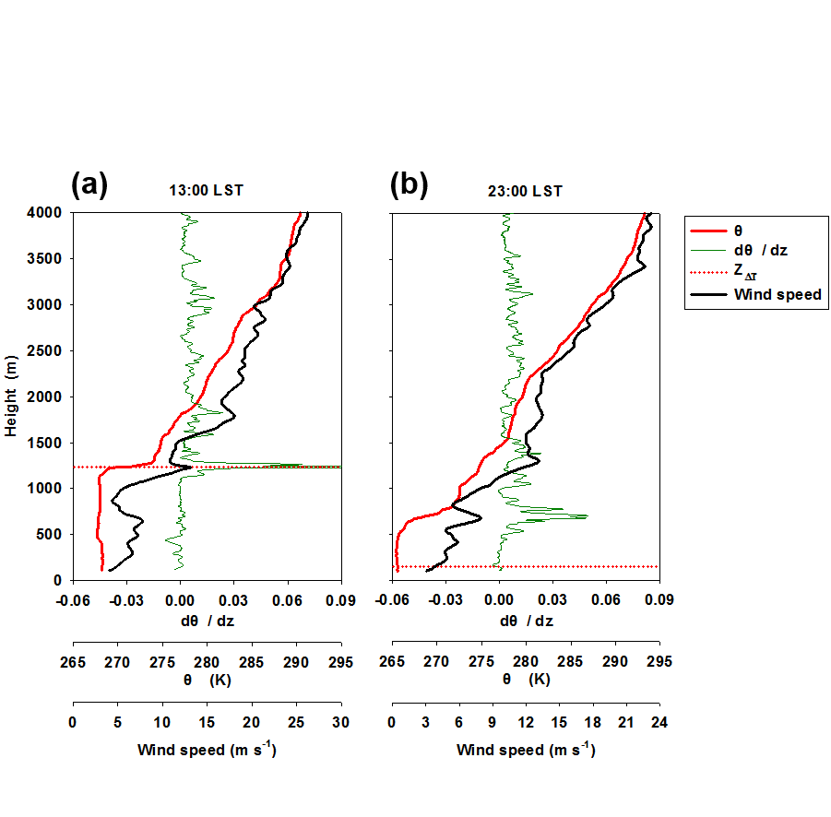

Figure 1: Representative thermodynamic profiles at day and night retrieved from radiosondes launched on 29 December 2016 at 13:00 h and 23:00 h, respectively. Profiles of potential temperature (), vertical gradient of potential temperature, and wind speed are depicted in in red, green, and black, respectively. The retrieved *Z*△T is indicated by a dotted line.

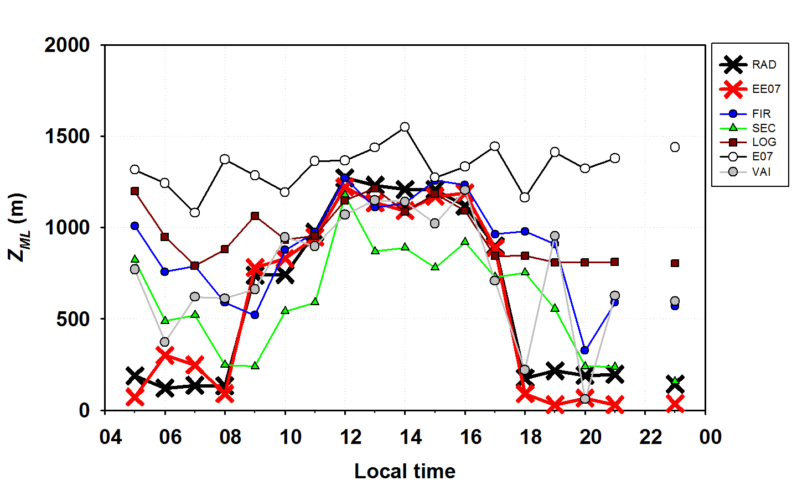

Figure 2: Retrieved *Z*△T and *Z*ML on 29 December 2016 from thermodynamic radiosonde profiles (RAD) and the six algorithms (see Table 1 for the definition) evaluated in this study based on the gradient method using attenuated aerosol backscatter profiles measured by a commercial ceilometer.

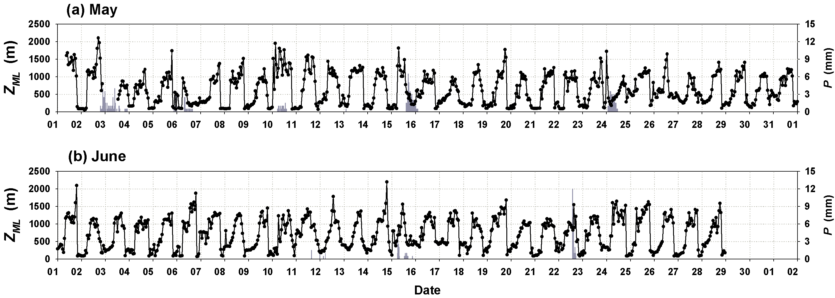

Figure 3: Time series of retrieved *Z*ML using the improved gradient method proposed here for the complete two-month campaign (May-June 2016). Precipitation events are indicated by grey bars.

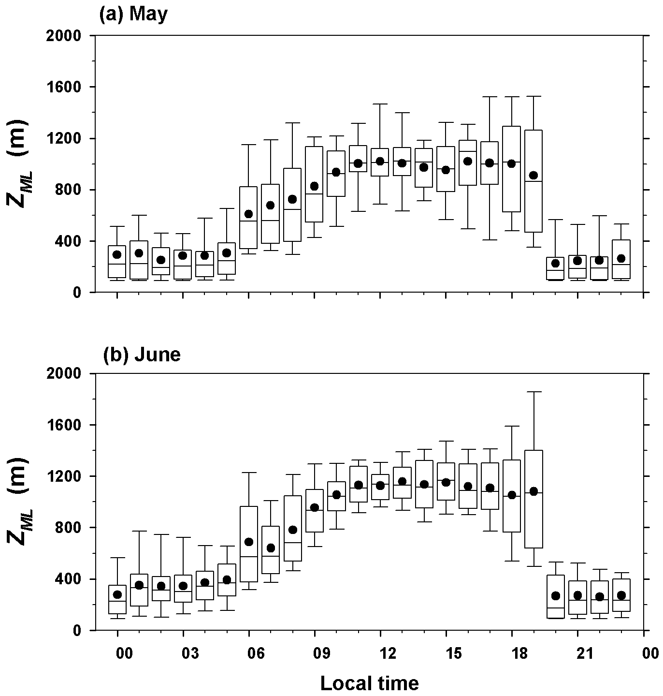

Figure 4: Box plots of the retrieved *Z*ML using the improved gradient method proposed here for each one of the two months of the campaign carried on May and June, 2016. The horizontal lines and black dots within each box are median and mean hourly values, respectively. The top and bottom of the boxes represent the 75th and 25th percentiles, while the whiskers extend to the 10th and 90th percentiles, respectively.

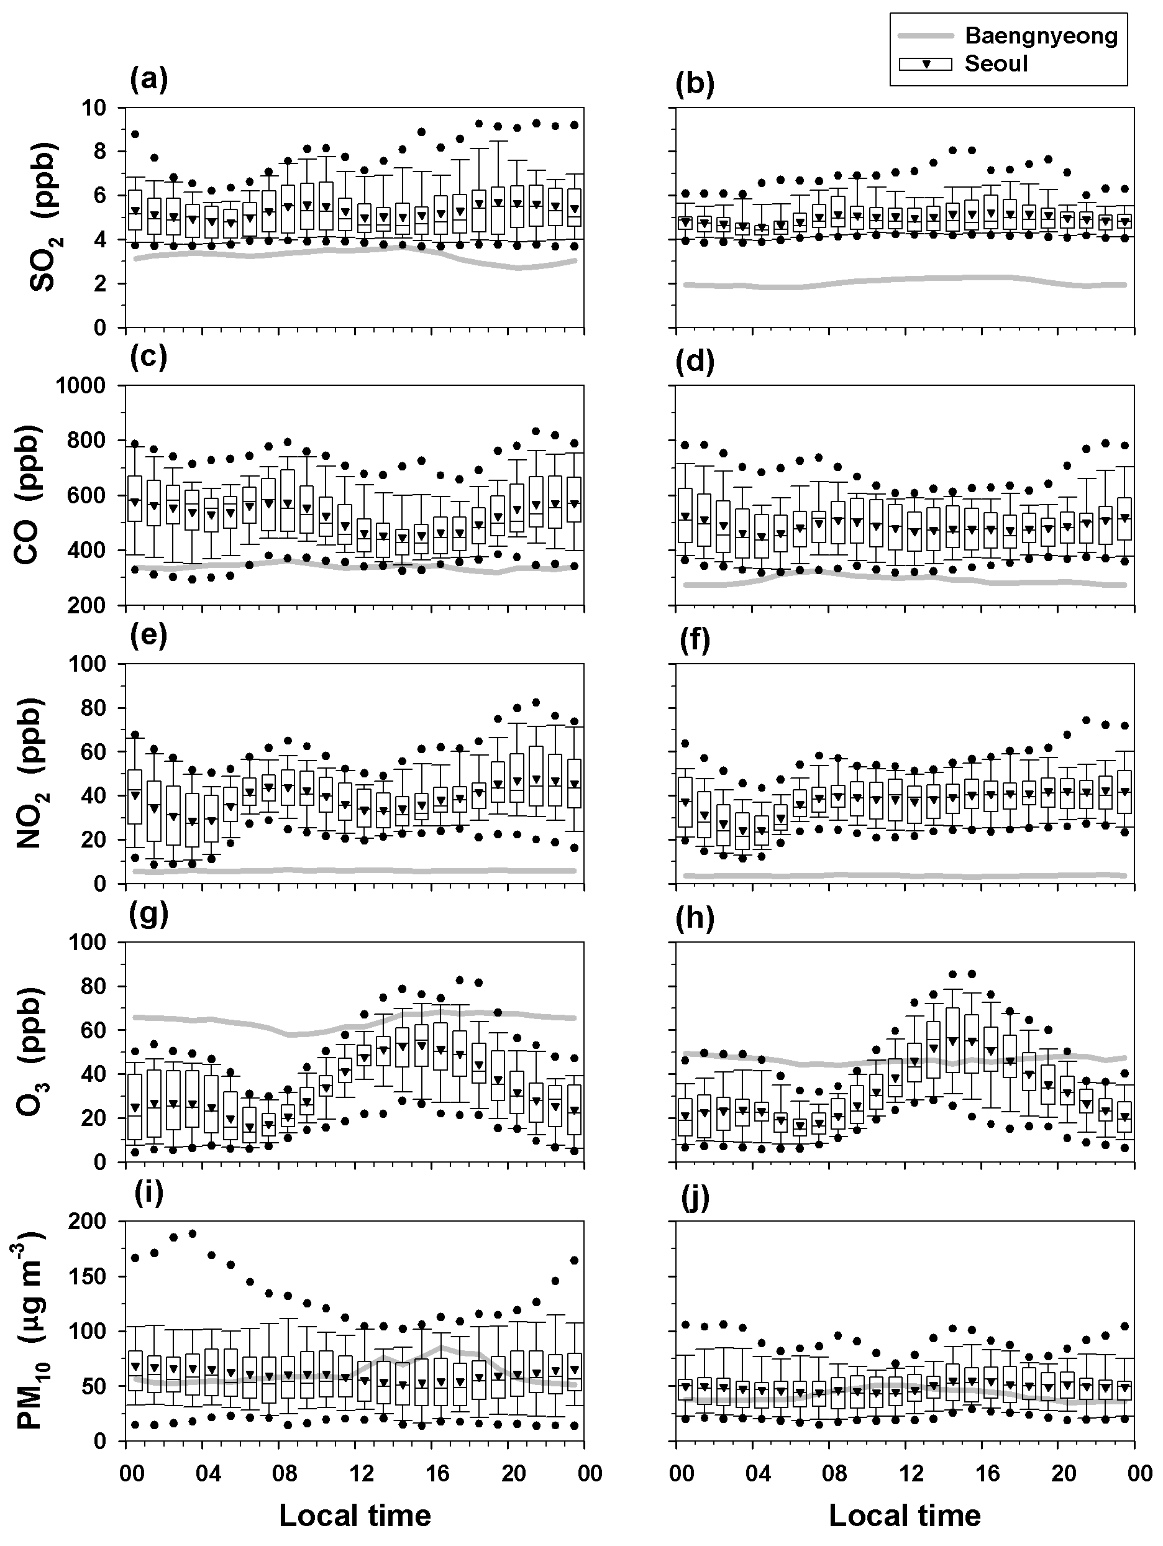

Figure 5: Diurnal patterns of ambient concentrations of SO2, CO, NO2, O3, and PM10 within the metropolitan area of Seoul (box plot) and at the background monitoring station of Baengnyeong island (gray line) during May (left) and June (right) 2016. Seoul’s concentrations include data from 38 stations across the city. Box plot indicates median, 25th, and 75th with box, 10th and 90th with whisker, 5th and 95th with a circle, and mean with a triangle.

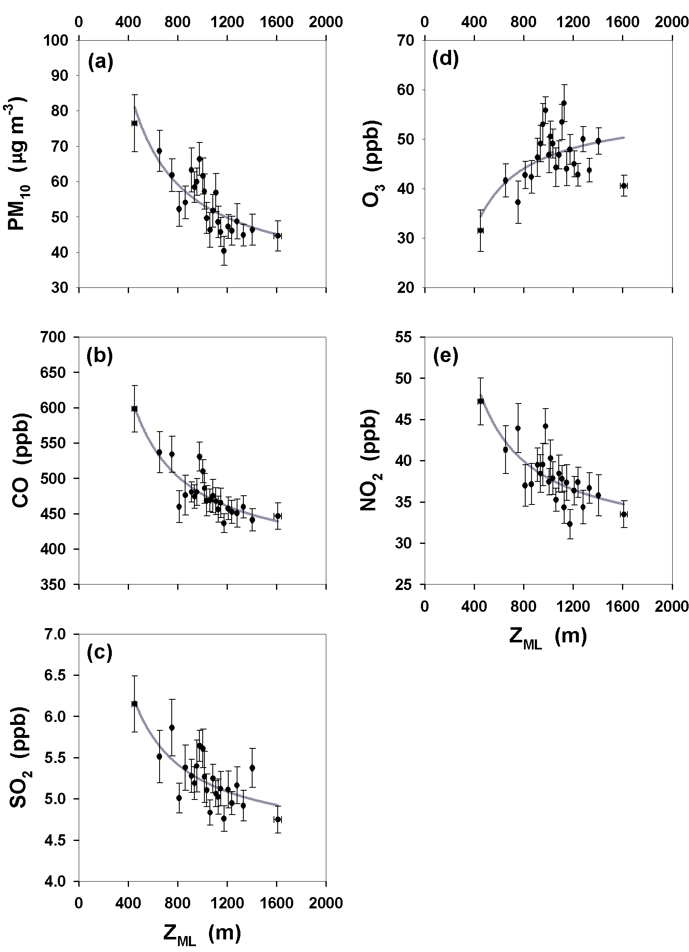

Figure 6: Inverse regressions of first order between retrieved *Z*ML and pollutants concentration during a daytime (09:00-18:00) showing the dilution effect caused by the evolution of the convective ML. Hourly data from May and June 2016 are included. Periods affected by precipitation are not considered and error bars indicate their standard errors. Each point is an ensemble of 20 points (n=20).